|  |
| --- |
|  |
| Auto Teller Machine |
| SETUP FOR NAPAS INTERFACE |
|  |
|  |
|  |

|  |  |
| --- | --- |
| Prepared for : | OCB Bank |
| Version of Document : | 1.1 |
| Status : | Draft |
| Release Date : | 3/2/2018 |
| Prepared by : | OpenWay Asia |
| Author : | Le Khanh Trinh |
| Owner : | OpenWay Asia |

**Contents**

**I.** **Way4 Settings** 3

1.2 Message Channel 3

1.3 Device Contract Type 3

1.4 Card Contract Type 5

1.5 Account Contract Types 7

1.6 Bank Account Scheme 7

1.7 Bank Accounting Contract 8

1.8 Bank Service Package 9

1.9 Routing 12

1.10 Bank Service Package 14

1.11 Device Service Package 15

**II.** **Transaction Switch Settings** 16

2.1 NAPAS channel (NapasBase.s.xml) 16

2.2 NAPAS IBFT channel (NapasIbft.s.xml) 17

2.3 NAPAS VAS channel (NapasVas.s.xml) 18

2.4 Routing 19

**Introduction**

This document will show steps to configure NAPAS interface for ATM and POS base transactions, IBFT and Billing/Topup. It is written after implementing NAPAS interface for OCB Bank (OCB), Vietnam.

This document is read by users who have knowledge of fields as information technology, card and merchant management.

This document is written by Openway Vietnam team. Thanks everyone for your support.

Document Version Control

|  |  |  |  |
| --- | --- | --- | --- |
| Date | Description of Change | Change done by | Approved By |
| 3rd Feb 2018 | V1.0 Initial draft | Le Khanh Trinh | Nguyen Ba Tu |
| 09 July 2018 | V1.1 Final | Le Khanh Trinh | Nguyen Ba Tu |

1. **Way4 Settings**

## Message Channel

Menu: OpenWay\Full\Configuration Setup\Main Tables\Message Channels

Purpose: Define Banknetvn Channel

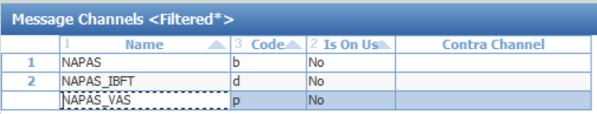

Detail as:

NAPAS – Code=b

NAPAS_IBFT – Code=d

NAPAS_VAS – Code = p

## Device Contract Type

Menu: OpenWay\Full\Configuration Setup\Contract Types\Device Contract Types

Purpose: Define NAPAS Device Contract in WAY4

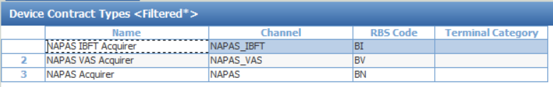

Define 3 device contract type as:

|  |  |  |
| --- | --- | --- |
| **Name** | **Channel** | **RBS Code** |
| NAPAS IBFT Acquirer | NAPAS_IBFT | BI |
| NAPAS VAS Acquirer | NAPAS_VAS | BV |
| NAPAS Acquirer | NAPAS | BN |

Click “Sub Types” and information as below screen:

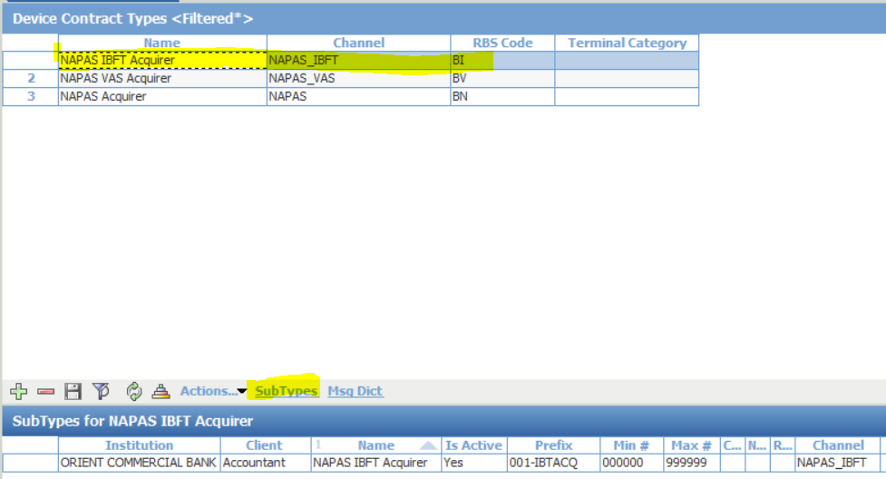

* Choose “NAPAS IBFT Acquirer” and click “**SubTypes**”
  + Institution: ORIENT COMMERCIAL BANK
  + Client: Accountant
  + Name: NAPAS IBFT Acquirer
  + Is Active: Yes
  + Prefix: 001-IBTACQ
  + Min#: 000000
  + Max#: 999999
  + Channel: NAPAS_IBFT

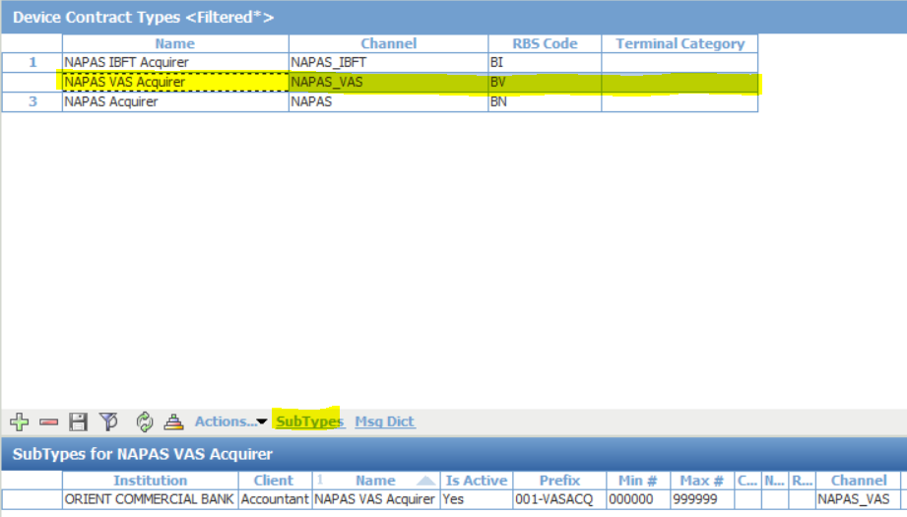

* Choose “NAPAS VAS Acquirer” and click “**SubTypes**”
  + Institution: ORIENT COMMERCIAL BANK
  + Client: Accountant
  + Name: NAPAS VAS Acquirer
  + Is Active: Yes
  + Prefix: 001-VASACQ
  + Min#: 000000
  + Max#: 999999
  + Channel: NAPAS_VAS

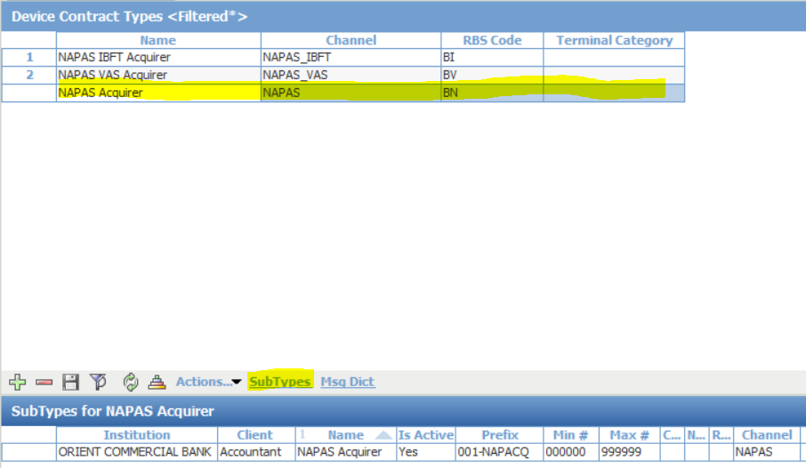

* Choose “NAPAS Acquirer” and click “**SubTypes**”
  + Institution: ORIENT COMMERCIAL BANK
  + Client: Accountant
  + Name: NAPAS Acquirer
  + Is Active: Yes
  + Prefix: 001-NAPACQ
  + Min#: 000000
  + Max#: 999999
  + Channel: NAPAS

## Card Contract Type

Menu: OpenWay\Full\Configuration Setup\Contract Types\Card Contract Types

Purpose: Define NAPAS Card Contract in WAY4

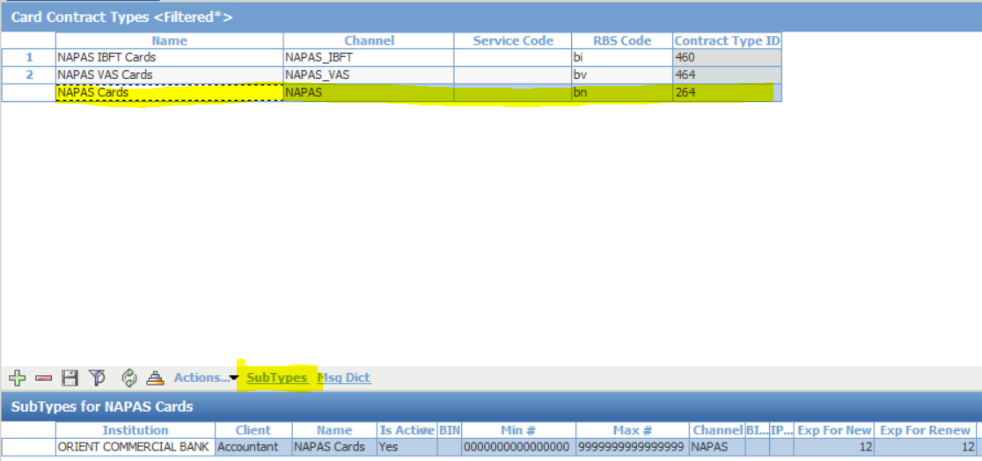

* Choose “NAPAS Cards” and click “**SubTypes**”:
  + Institution: ORIENT COMMERCIAL BANK
  + Client: Accountant
  + Name: NAPAS Cards
  + Is Active: Yes
  + BIN:
  + Min#: 0000000000000000
  + Max#: 9999999999999999
  + Channel: NAPAS
  + Exp For New: 12
  + Exp For Renew: 12

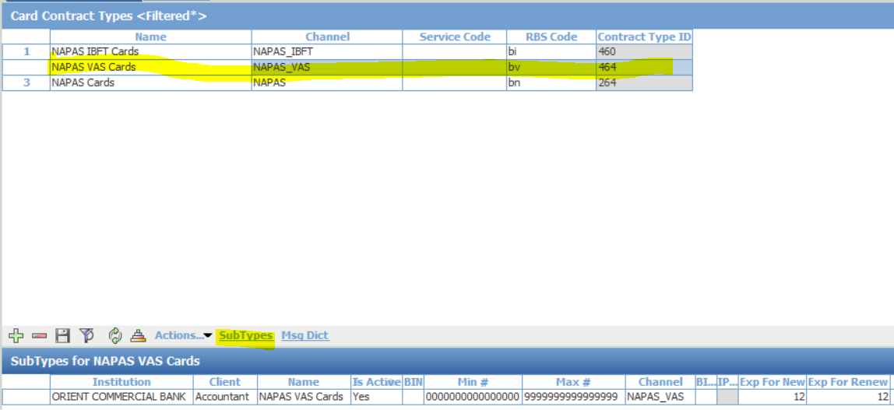

* Choose “NAPAS VAS Cards” and click “**SubTypes**”:
  + Institution: ORIENT COMMERCIAL BANK
  + Client: Accountant
  + Name: NAPAS VAS Cards
  + Is Active: Yes
  + BIN:
  + Min#: 0000000000000000
  + Max#: 9999999999999999
  + Channel: NAPAS_VAS
  + Exp For New: 12
  + Exp For Renew: 12

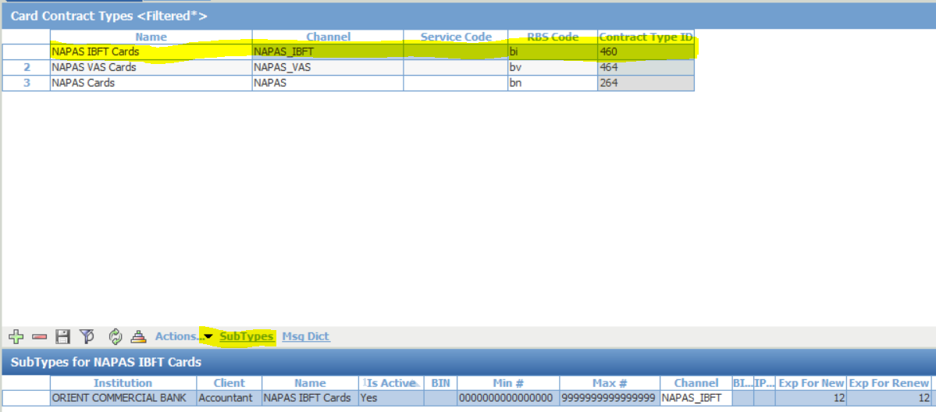

* Choose “NAPAS IBFT Cards” and click “**SubTypes**”:
  + Institution: ORIENT COMMERCIAL BANK
  + Client: Accountant
  + Name: NAPAS IBFT Cards
  + Is Active: Yes
  + BIN:
  + Min#: 0000000000000000
  + Max#: 9999999999999999
  + Channel: NAPAS_IBFT
  + Exp For New: 12
  + Exp For Renew: 12

## Account Contract Types

Menu: OpenWay\Full\Configuration Setup\Contract Types\Accounting Contract Types

Purpose: Define Napas Accounting Contract in WAY4

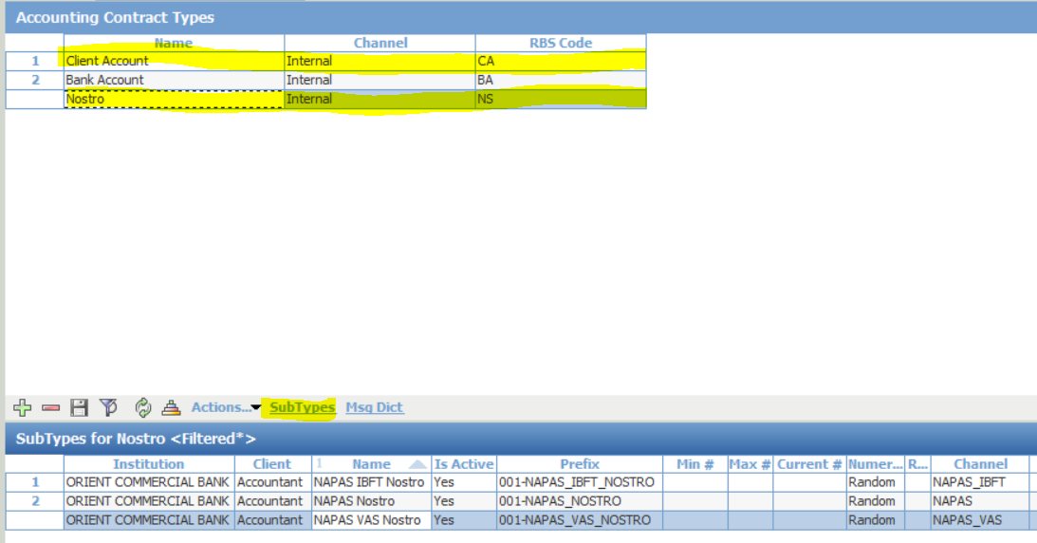

* Select Accounting Contract “**Nostro**” and click “**SubTypes**”
* In “**SubTypes**” of “**Nostro**” click “**Ins**” to create new accounting contract for NAPAS IBFT Nostro, NAPAS Nostro and NAPAS VAS Nostro.

.

## Bank Account Scheme

Menu: OpenWay\Full\Configuration Setup\Accounting Setup\Bank Account Schemes

Purpose: Define NAPAS Account Scheme in WAY4

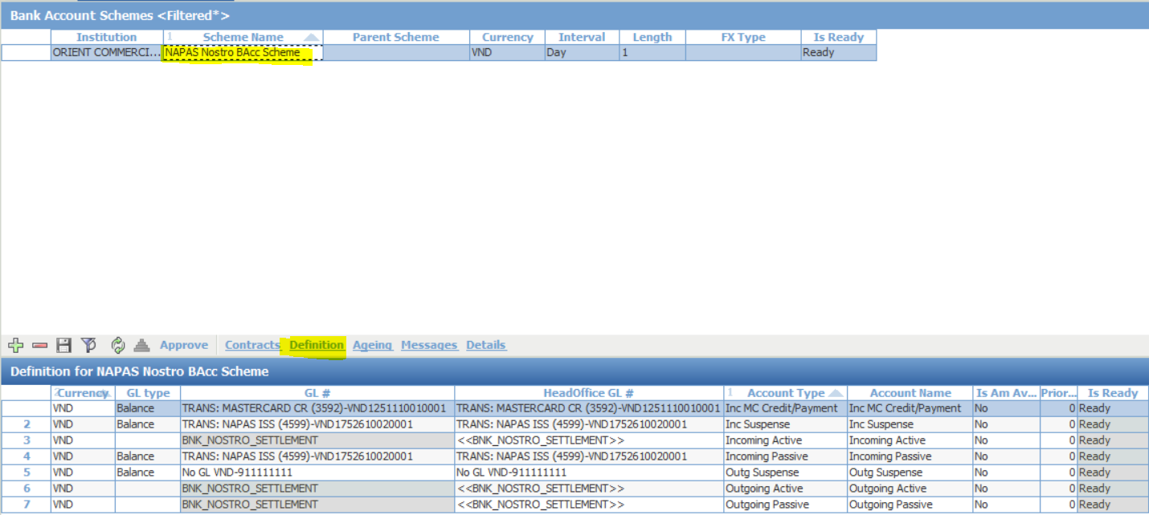

## Bank Accounting Contract

Menu: OpenWay\Full\Configuration Setup\Accounting Setup\Bank Accounting Contracts

Purpose: Define NAPAS Accounting Contract in WAY4 Account Contract

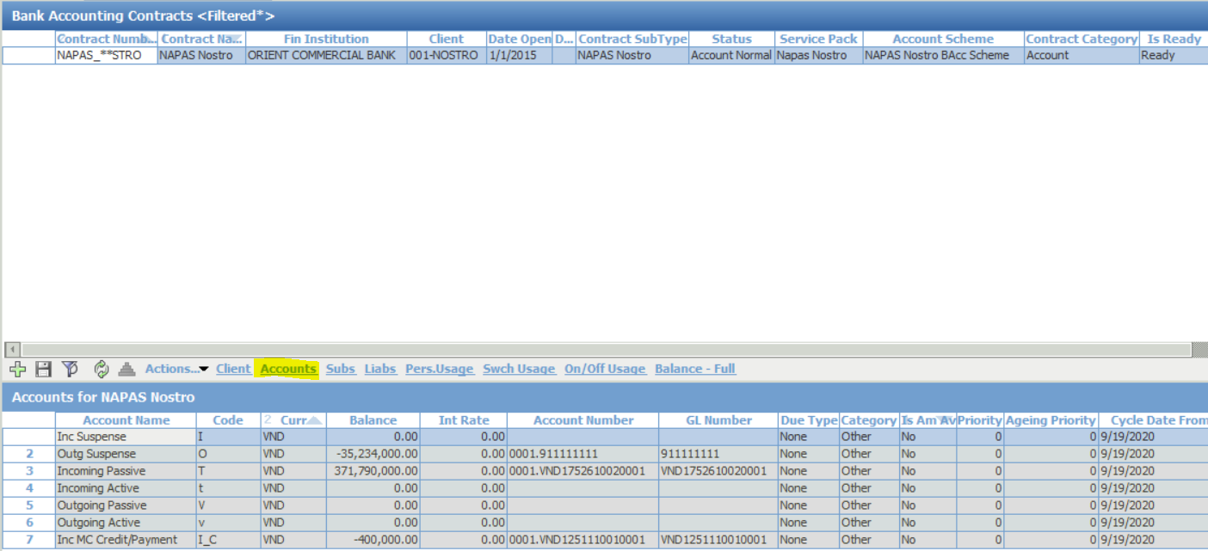

* Click “**Ins**” to create new NAPAS Bank Accounting Contract
  + Contract#: NAPAS_NOSTRO
  + Contract name: NAPAS Nostro
  + Category: Account
  + Institution: ORIENT COMMERCIAL BANK
  + Accounting Scheme: Banknetvn Nostro BAcc Scheme
  + Bank Division: 001-NOSTRO
  + Contract Type: NAPAS Nostro
  + Service Pack: Napas Nostro
  + Keep Entries: Group
* Click “**Sub**” to create sub bank accounting contracts. Detail as following:

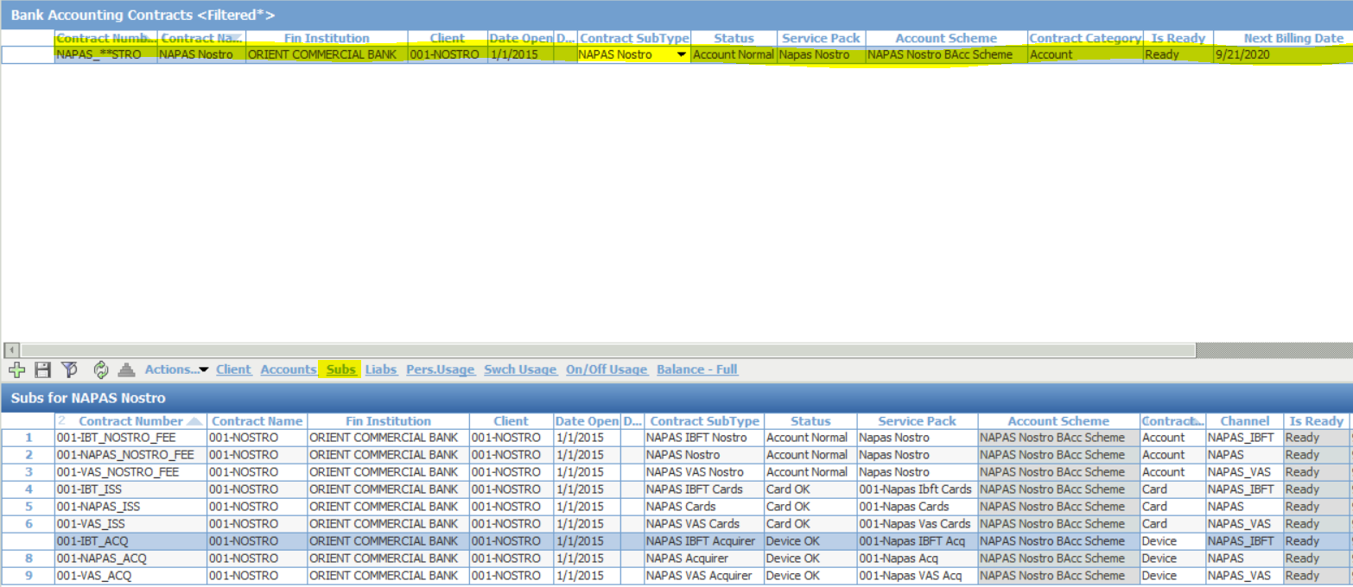

* Click **“Action”** 🡪 “**Approve**” to apply this configuration.

## Bank Service Package

Menu: OpenWay\Full\Configuration Setup\Accounting Setup\Bank Service Packs

Purpose: Add Fee Contract to Bank Service Packs

**Account Service Package**

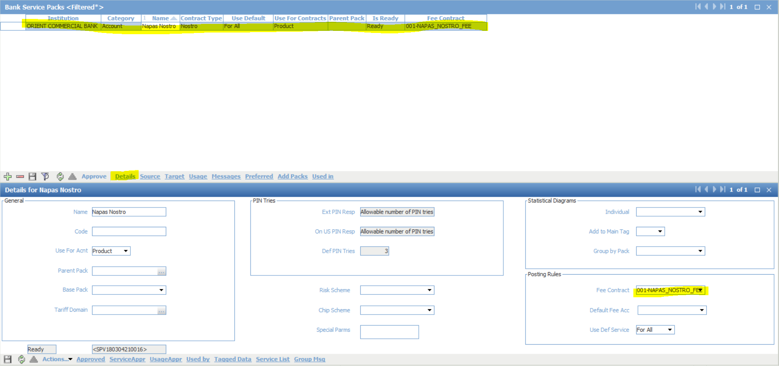

**Device Service Package**

001-Napas Acq

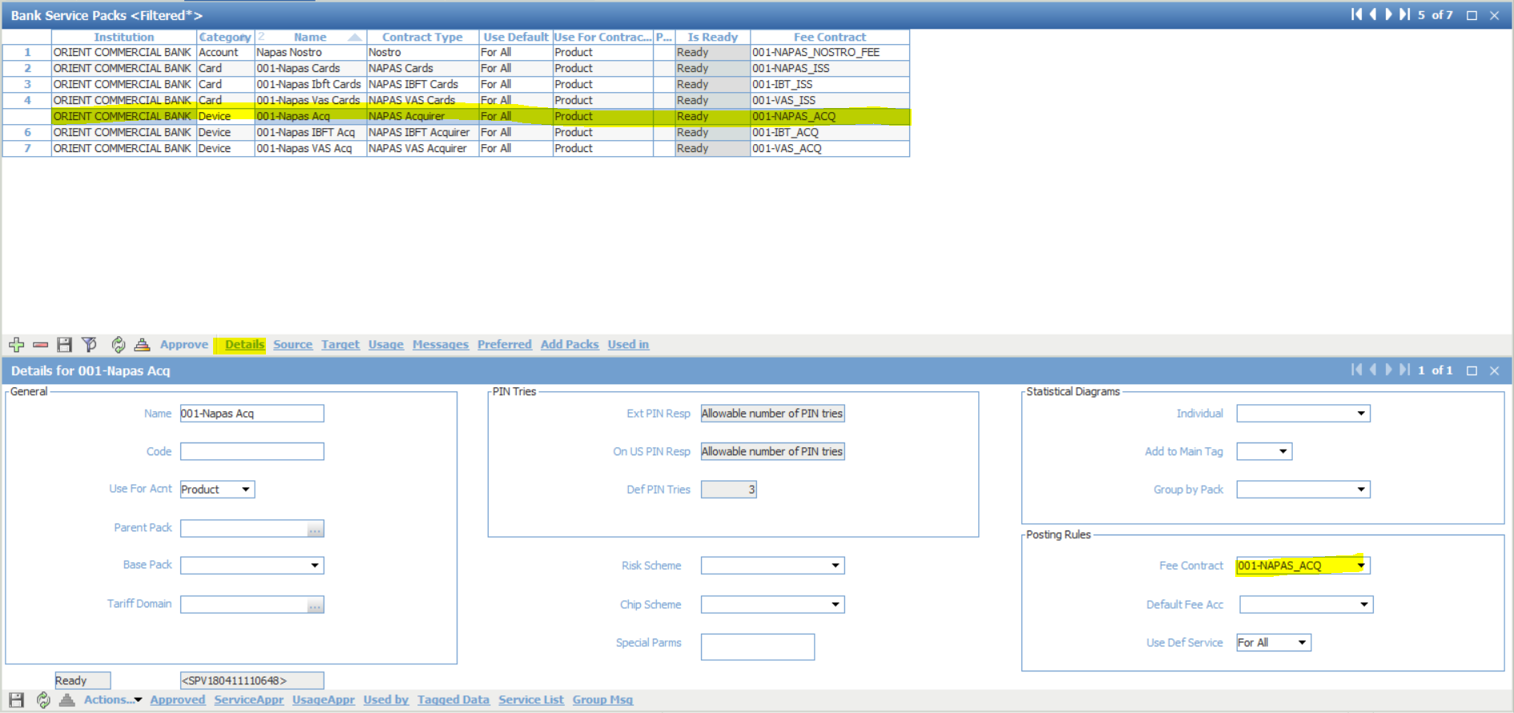

001-Napas IBFT Acq

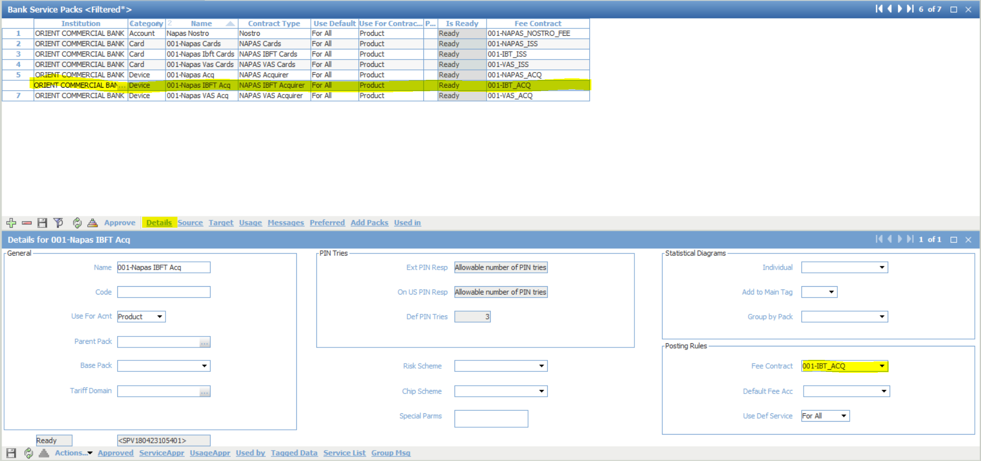

001-Napas VAS Acq

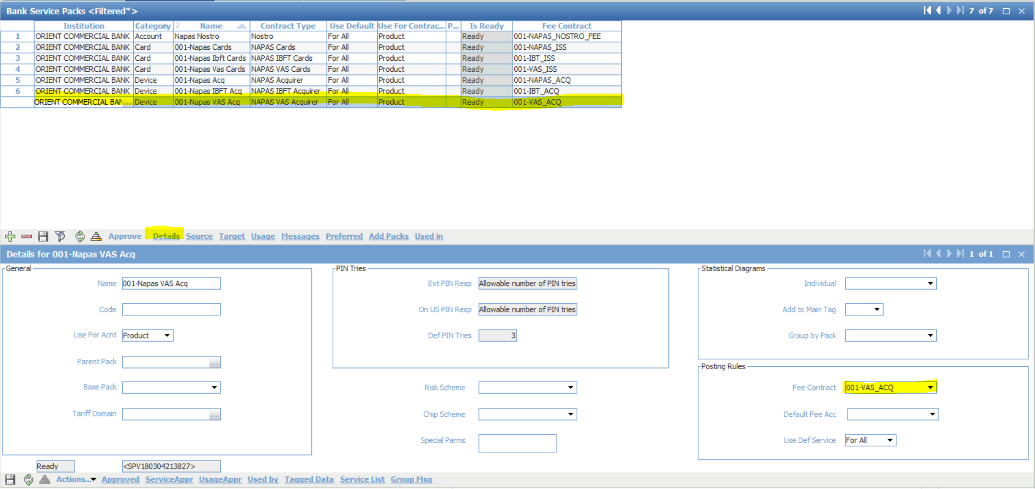

**Card Service Package**

001-Napas Cards

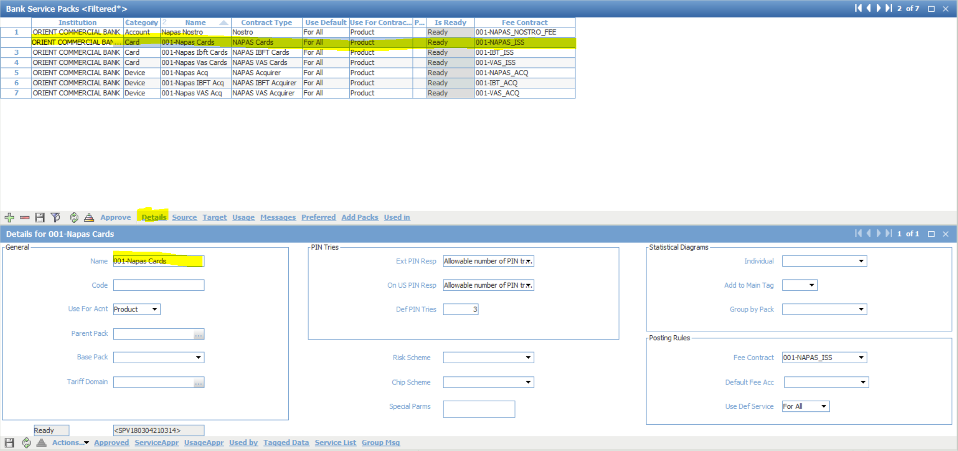

001-Napas Ibft Cards

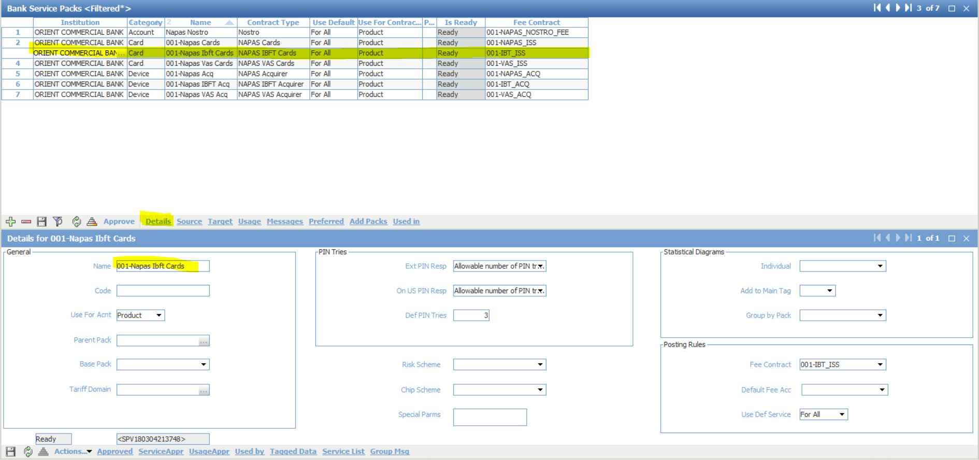

001-Napas Vas Cards

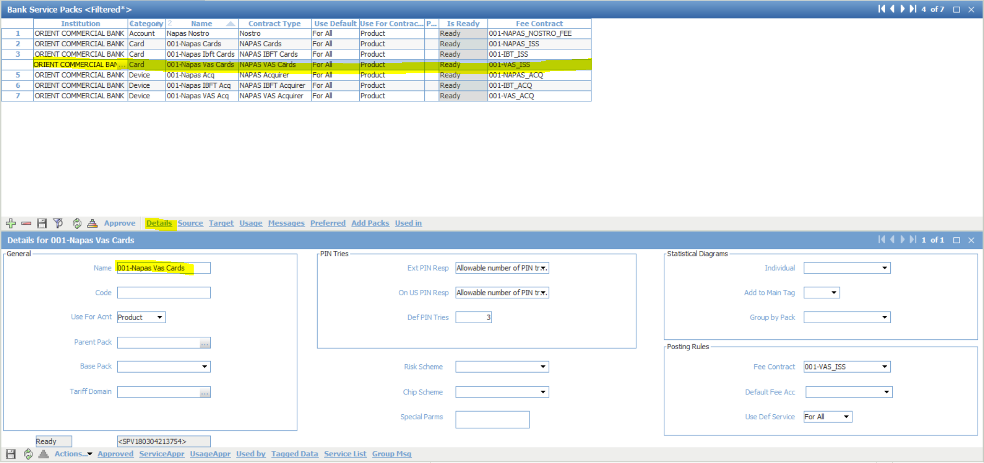

## Routing

Menu: OpenWay\Full\Configuration Setup\Routing\BIN Groups

Purpose: Define routing for Naps Account, Device and Card in WAY4

**BIN Group**

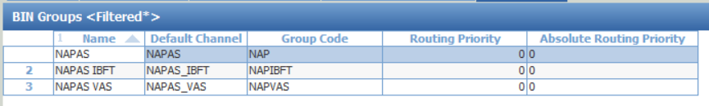

Define 3 Bin group for NAPAS, NAPAS IBFT and NAPAS VAS. Detail as above screen.

**Routing**

For NAPAS group

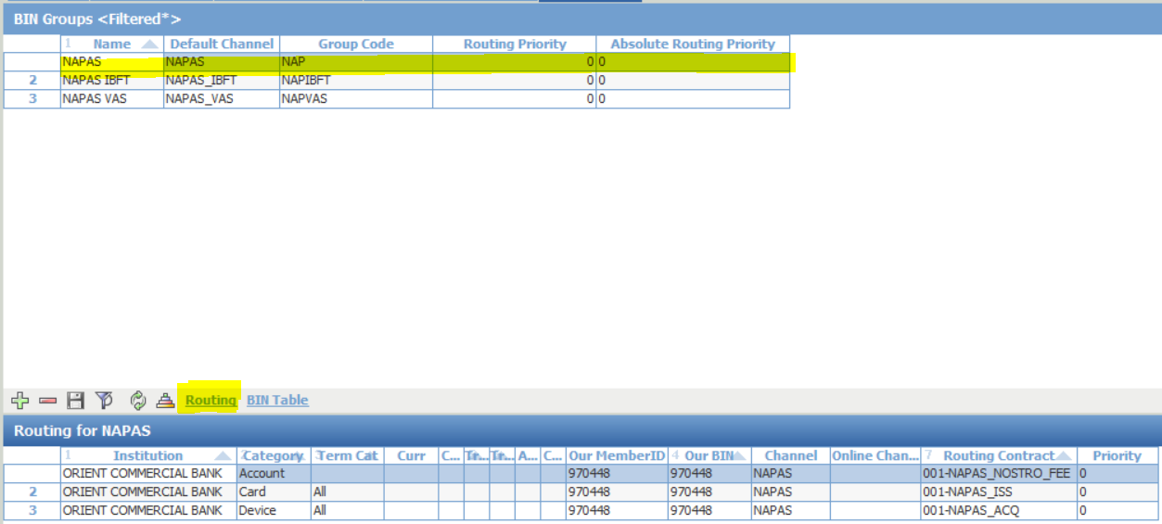

For NAPAS IBFT group

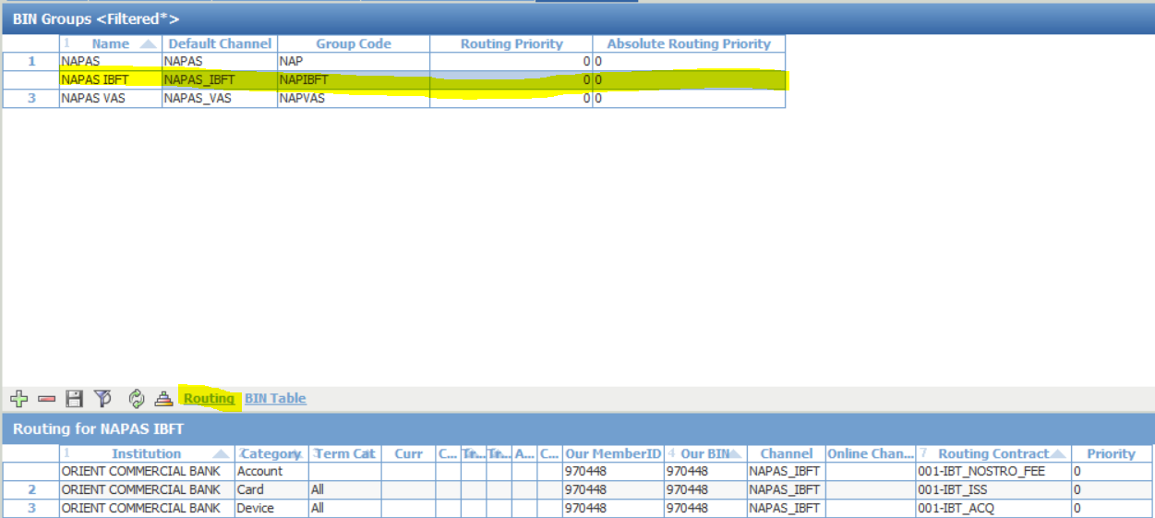

For NAPAS VAS group

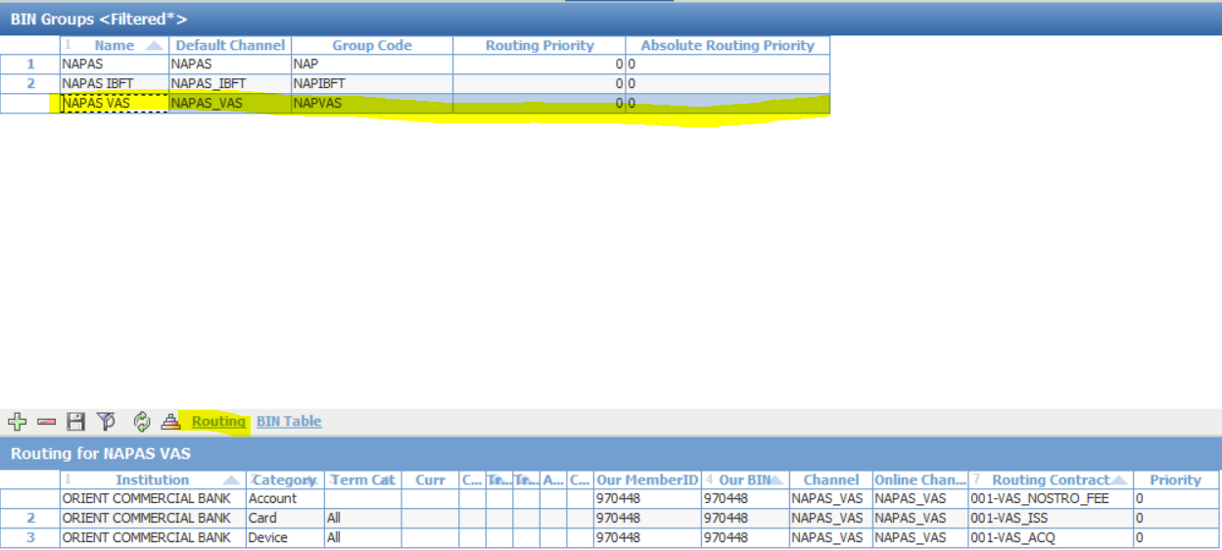

## Bank Service Package

Menu: OpenWay\Full\Configuration Setup\Accounting Setup\Bank Service Packs

Purpose: Define Target for [Branch local card] Pack

**001- Branch Local Cards**

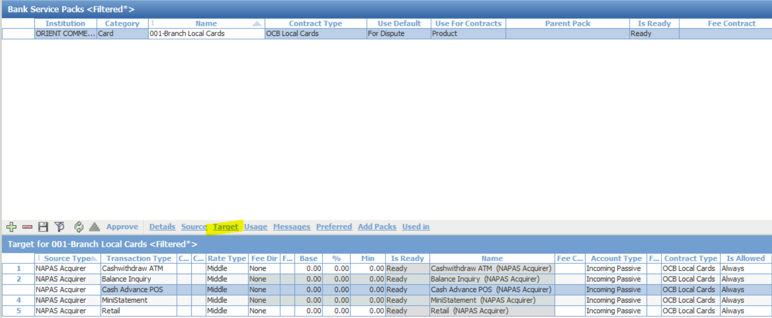

Choose Name = [001-Branch Local Cards]

Click on [Target] button

Click on [Ins] button to add 5 transaction types: ATM, Cash, Balance Inquiry, Mini Statement and Retail

Click on [Approve] to approve service pack.

**001-Napas Acq**

Define 6 transactions (ATM, Cash, Credit Account BNV, MiniStatement, Balance Inquiry and Retail)

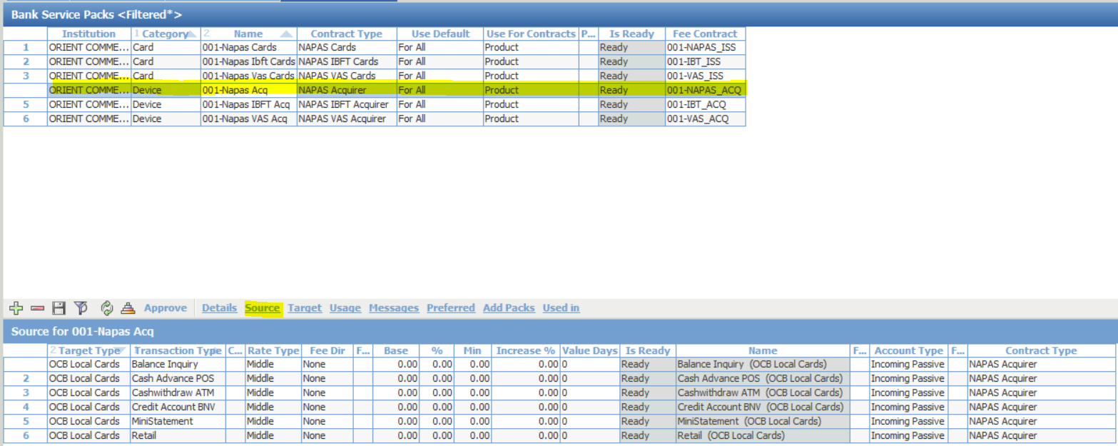

001-Napas Ibft Acq

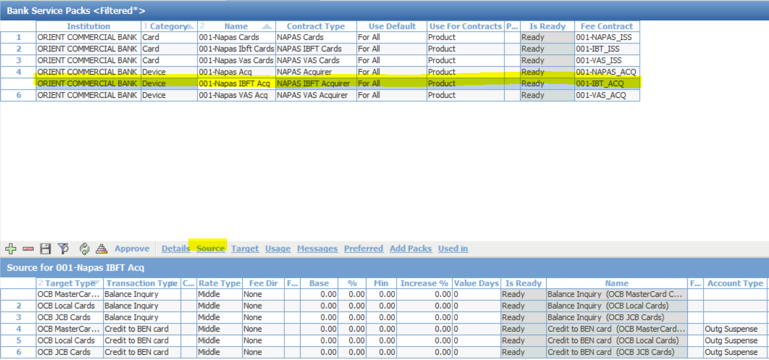

## Device Service Package

Menu: OpenWay\Full\Configuration Setup\Products\Acquiring Products\Device Service Packs

Purpose: Define Bank’s device to accept Banknetvn Cards

OCB ATM Device Svr

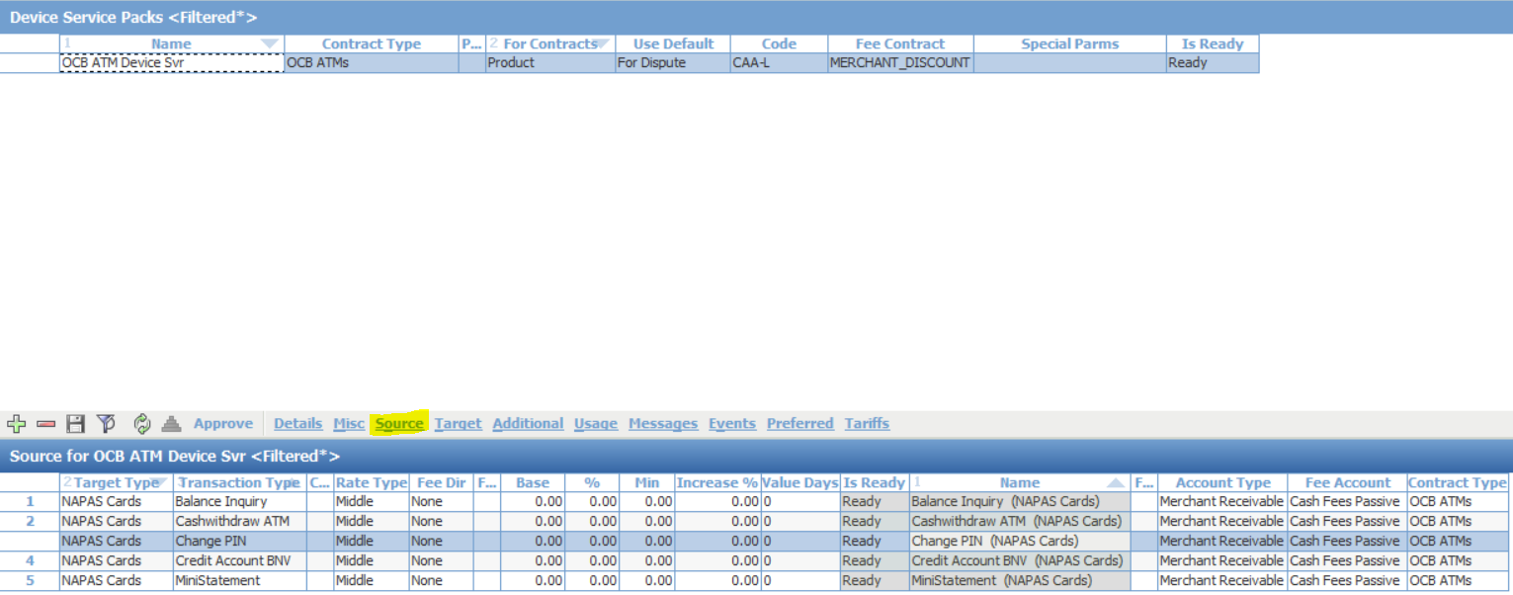

OCB POS Retail VND Dev Svr

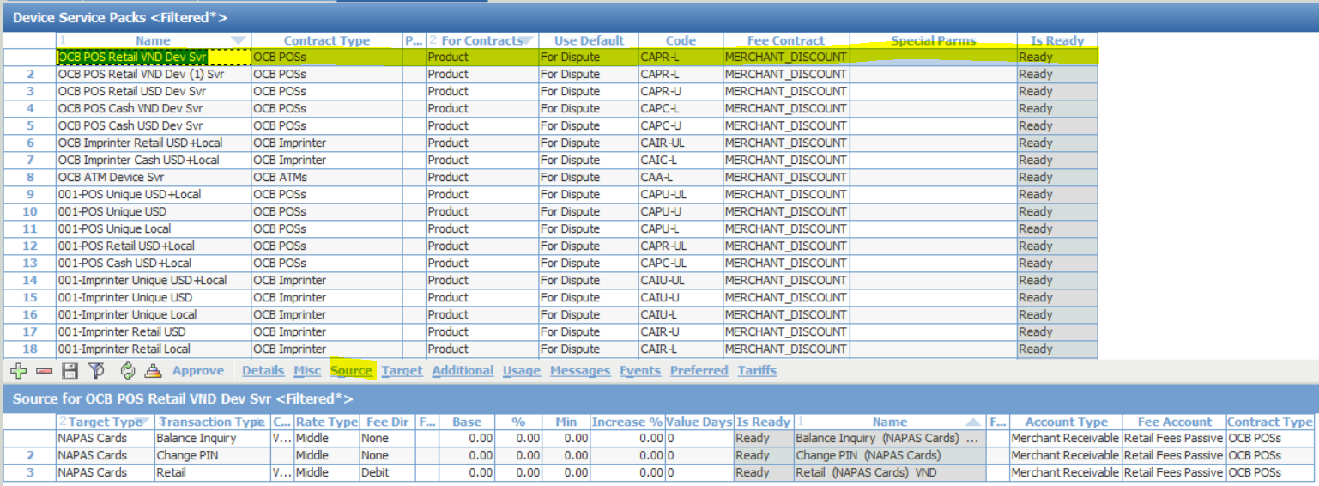

OCB POS Retail USD Dev Svr

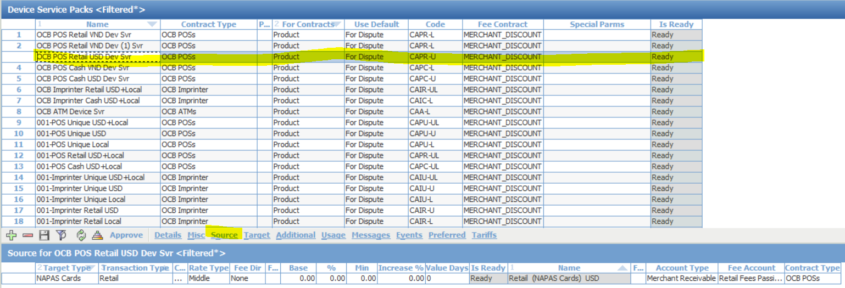

1. **Transaction Switch Settings**

## NAPAS channel (NapasBase.s.xml)

For NAPAS Base interface, the configuration file is NapasBase.s.xml.

|  |
| --- |
| **Channel Name** |
| <service xmlns:xsi="http://www.w3.org/2001/XMLSchema-instance" xsi:noNamespaceSchemaLocation="../../temp/ts-config.xsd" address="NapasBase" storeServiceId="B1" singleton="true" autoStarted="true"> |

|  |
| --- |
| **IP/Port Connection** |
| <transport xsi:type="ExternalClient" host="192.168.88.4" port="10056" name="NapasBase" dump="true"> |

|  |
| --- |
| **ISO dialect** |
| <dialect  file = "iso_dialects/h2hbankn.prm"  messageFormat="HEX_ISO"  defaultCoding="ASC"  messageCoding="ASC"  /> |

|  |
| --- |
| **Networking and Key exchange** |
| <nettest_options resend_nettest_interval="60"/>  <pin_options>  <dynamic fastKeyChange="true" keyExchangeOnDemand="true" hmk="U0B892B45C830B0C321837A80AA64001B"/>  </pin_options>  <timing_options response_timeout="60"/> |

## NAPAS IBFT channel (NapasIbft.s.xml)

For NAPAS IBFT interface, the configuration file is NapasIbft.s.xml.

|  |
| --- |
| **Channel Name** |
| <service xmlns:xsi="http://www.w3.org/2001/XMLSchema-instance" xsi:noNamespaceSchemaLocation="../../temp/ts-config.xsd"  address="NapasIbft"  storeServiceId="b2"  singleton="true"  autoStarted="true"  > |

|  |
| --- |
| **IP/Port Connection** |
| <transport  xsi:type="ExternalClient"  host="10.255.252.248"  port="11089"  name="NapasIbft"  dump="true"  > |

|  |
| --- |
| **ISO dialect** |
| <dialect  file = "iso_dialects/h2hbankv.prm"  messageFormat="HEX_ISO"  defaultCoding="ASC"  messageCoding="ASC"  /> |

|  |
| --- |
| **Networking and Key exchange** |
| <nettest_options resend_nettest_interval="120"/>  <pin_options zpk="UA105E1DBB7BE5552C645DB9CC6E3EB5A" />  <special_processing_options sourceChannelID="d"/>  <!-- signon_options first_signon="1" resend_signon_interval="20"/ -->  <timing_options response_timeout="60"/> |

## NAPAS VAS channel (NapasVas.s.xml)

For NAPAS IBFT interface, the configuration file is NapasIbft.s.xml.

|  |
| --- |
| **Channel Name** |
| <service xmlns:xsi="http://www.w3.org/2001/XMLSchema-instance" xsi:noNamespaceSchemaLocation="../../temp/ts-config.xsd"  address="NapasVas"  storeServiceId="b3"  singleton="true"  autoStarted="true"  > |

|  |
| --- |
| **IP/Port Connection** |
| <transport  xsi:type="ExternalClient"  host="10.255.252.55"  port="30109"  name="NapasVas"  dump="true"  > |

|  |
| --- |
| **ISO dialect** |
| <dialect  file = "iso_dialects/h2hbankb.prm"  messageFormat="ISO8583"  defaultCoding="ASC"  messageCoding="ASC"  /> |

## Routing

|  |
| --- |
| **Routing** |
| <?xml version="1.0" encoding="UTF-8"?>  <service xmlns:xsi="http://www.w3.org/2001/XMLSchema-instance" xsi:noNamespaceSchemaLocation="../../temp/ts-config.xsd">  <appComponent xsi:type="AppRoutingService">  <!--Routing OTP generate/verify message to other gateway-->  <rule sourceService="NapasBase" protocol="iss_fp" tags="RID:111222" targetAddress="NapasEcom" name="Routing card verify message" />  <rule sourceService="NapasBase" protocol="iss_fp" tags="RID:111333" targetAddress="NapasEcom" name="Routing OTP verify message" />    <!-- Get Account Name in FT -->  <rule sourceService="IntraLnkAdapter" protocol="iss_fp" tags="RID:444444" targetAddress="RBS" name="Routing OFT to CBS to get account name" />    <!-- Biling Topup service -->  <rule sourceService="IntraLnkAdapter" protocol="iss_fp" tags="RID:000004" targetAddress="NapasVas" name="Routing to NAPASVAS Inquiry target information" />  <rule sourceService="IntraLnkAdapter" protocol="iss_fp" tags="RID:000006" targetAddress="NapasVas" name="Routing Billing/Topup Deposite to NAPASVAS" />    <!-- IBFT Service -->  <rule sourceService="IntraLnkAdapter" protocol="iss_fp" tags="RID:000005" targetAddress="NapasIbft" name="Routing to NAPASIBFT Inquiry target information" />  <rule sourceService="IntraLnkAdapter" protocol="iss_fp" tags="RID:000007" targetAddress="NapasIbft" name="Routing IBFT Deposite to NAPASIBFT" />  <rule sourceService="IntraLnkAdapter" protocol="iss_fp" tags="RID:888888" targetAddress="IRouter" name="Revert for IBFT, Billing/Topup" />  <!-- Voice Authorization Transaction -->  <rule sourceService="Intranet" protocol="iss_fp" tags="TCH:E" targetAddress="MC_CREDIT" name="Voice Authorization"/>    <!-- Our ATM-IPS Cards -->  <rule sourceService="IntraLnkAdapter" protocol="iss_fp" tags="TCH:D" targetAddress="MC_DEBIT" name="Our ATM-MC Cards"/>  <rule sourceService="IntraLnkAdapter" protocol="iss_fp" tags="TCH:J" targetAddress="JCB_SMS" name="Our ATM-JCB Cards"/>  <rule sourceService="IntraLnkAdapter" protocol="iss_fp" tags="TCH:b" targetAddress="NapasBase" name="Our ATM-NAPAS Cards-Base services"/>  <!-- Our POS-IPS Cards -->  <rule sourceService="AcqService" protocol="iss_fp" tags="TCH:E" targetAddress="MC_CREDIT" name="Our POS-MC Cards"/>  <rule sourceService="AcqService" protocol="iss_fp" tags="TCH:J" targetAddress="JCB_DMS" name="Our POS-JCB Cards"/>  <rule sourceService="AcqService" protocol="iss_fp" tags="TCH:b" targetAddress="NapasBase" name="Our POS-NAPAS Cards-Base services"/>  <!-- Our Devices-Our Cards -->  <rule protocol="iss_fp" tags="TCH:O" targetAddress="IRouter" name="Our Devices-Our Cards"/>  <rule protocol="iss_fp" tags="TCH:e" targetAddress="IRouter" name="Our Devices-Our MC Cards"/>  <rule protocol="iss_fp" tags="TCH:j" targetAddress="IRouter" name="Our Devices-Our JCB Cards"/>  <!-- IPS ACQ-Our Cards -->  <rule sourceService="MC_CREDIT" protocol="iss_fp" tags="TCH:e" targetAddress="IRouter" name="MC ACQ-Our MC Cards"/>  <rule sourceService="MC_CREDIT" protocol="iss_fp" tags="PAN:500000-599999" targetAddress="IRouter" name="MC ACQ-Our MC Cards"/>  <rule sourceService="JCB_DMS" protocol="iss_fp" tags="PAN:300000-399999" targetAddress="IRouter" name="JCB ACQ-Our JCB Cards"/>  <rule sourceService="NapasIbft" protocol="iss_fp" tags="*" targetAddress="IRouter" name="NAPAS ACQ-Our Local Cards"/>  <rule sourceService="NapasVas" protocol="iss_fp" tags="*" targetAddress="IRouter" name="NAPAS ACQ-Our Local Cards"/>  <rule sourceService="NapasBase" protocol="iss_fp" tags="*" targetAddress="IRouter" name="NAPAS ACQ-Our Local Cards"/>  <!--rule sourceService="JCB_DMS" protocol="iss_fp" tags="*" targetAddress="RBS" name="JCB TESTING...gan h2hbankj.prm cho kenh RBS + F39=00"/-->  <rule sourceService="DBFileUpdate" protocol="iss_fp" tags="TCH:J" targetAddress="JCB" name="DBFileUpdate-JCB" />    <!-- Routing to CBS -->  <!--rule sourceService="AuthService" protocol="iss_fp" tags="TCH:G" targetAddress="CBGService" name="Routing Debit Card to CBGService" /-->  <rule sourceService="IRouter" protocol="iss_fp" tags="TCH:B" targetAddress="RBS" name="Routing Debit card to CBS" />    <rule sourceService="IRouter" protocol="iss_fp" targetAddress="Nowhere" name="Forbid default redirection from AuthService"/>  </appComponent>  </service> |